LAB 3: THE WAVEFORM/FUNCTION GENERATOR AND OSCILLOSCOPE
Name:

Objective:
To learn how to use the waveform/function generator and the oscilloscope.

Learning Outcomes:
- The ability to use function generator to produce the desired ac signal.
- The ability to use the oscilloscope to measure the ac signal parameters.

Instrument/Component:
Waveform/Function Generator
Oscilloscope

Introduction:
Many experiments in the advanced labs make use of oscilloscopes and function generators that it is useful to learn their general operation.

Function generators are signal sources which provide a specifiable voltage applied over a specifiable time, such as a “sine wave” or “triangle wave” signal.

Oscilloscopes are a type of signal analyzer—they show the experimenter a picture of the signal, usually in the form of a voltage versus time graph. The user can then study this picture to learn the amplitude, frequency, and overall shape of the signal which may depend on the physics being explored in the experiment.

FUNCTION GENERATOR BASICS
Function generators have a few common features:
- A way to select a waveform type: sine, square, and triangle are most common, but some will give ramps, pulses, “noise”, or allow you to program a particular arbitrary shape.
- A way to select the waveform frequency. Typical frequency ranges are from 0.01 Hz to 10 MHz.
- A way to select the waveform amplitude.
- At least two outputs.

The “main” output, which is where you find the desired waveform, typically has a maximum voltage of 20 volts peak-to-peak, or ±10 volts range.

The most common output impedance of the main output is 50 ohms, although lower output impedances can sometimes be found.

A second output, sometimes called “sync”, “aux” or “TTL” produces a square wave with standard 0 and 5 volt digital signal levels. It is used for synchronizing another device (such as an oscilloscope) to the possibly variable main output signal.

A wide variety of other features are available on most modern function generators, such as “frequency sweep”—the ability to automatically vary the frequency between a minimum and maximum value, “DC offset”—a knob that adds a specified amount of DC voltage to the time-varying waveform, and extra inputs or outputs that can be used to control these extra features by other instruments.

The function generator used in the lab is the RIGOL DG4000 shown in Figure 3.1.

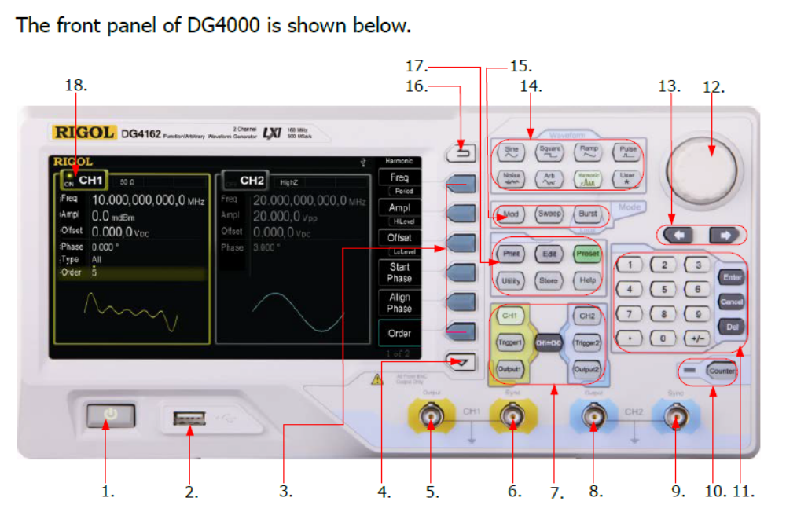
Figure 3.1

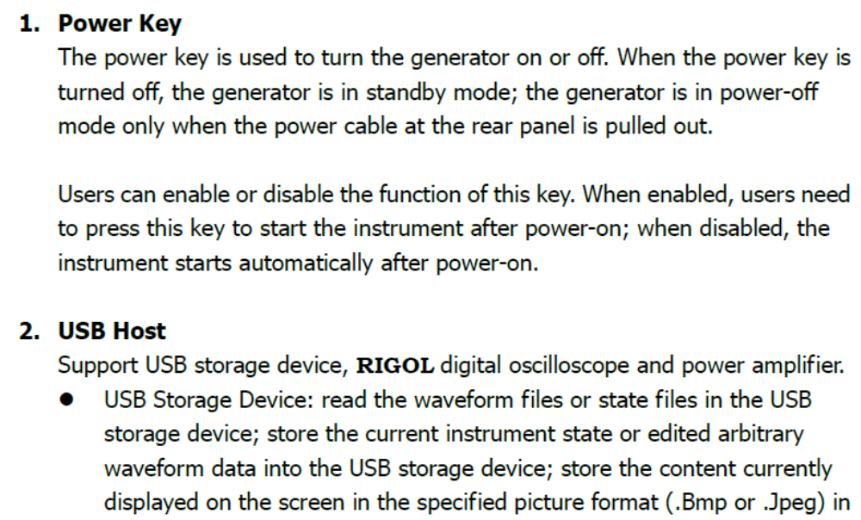

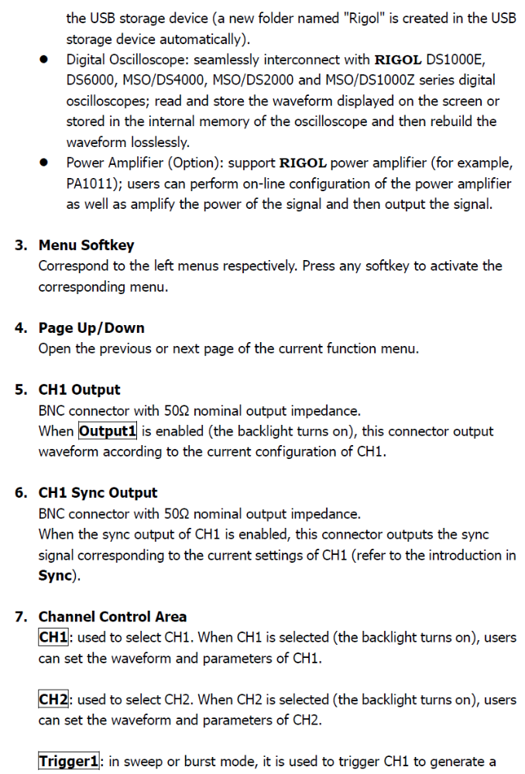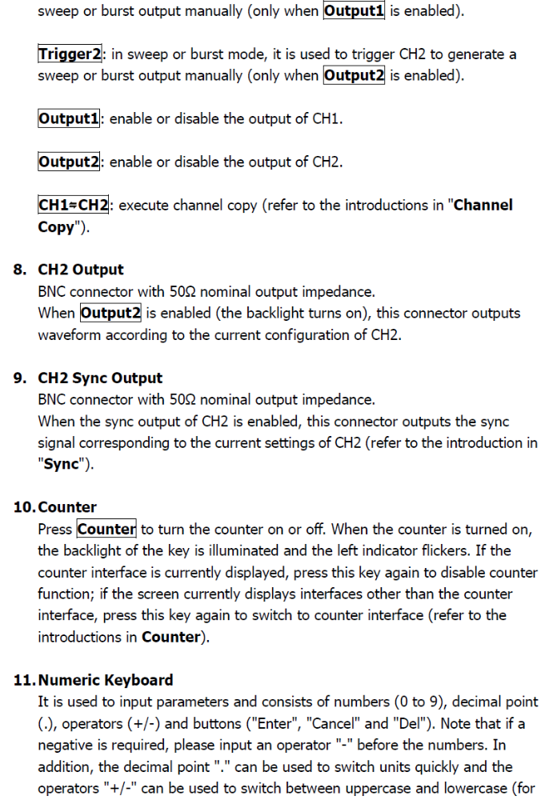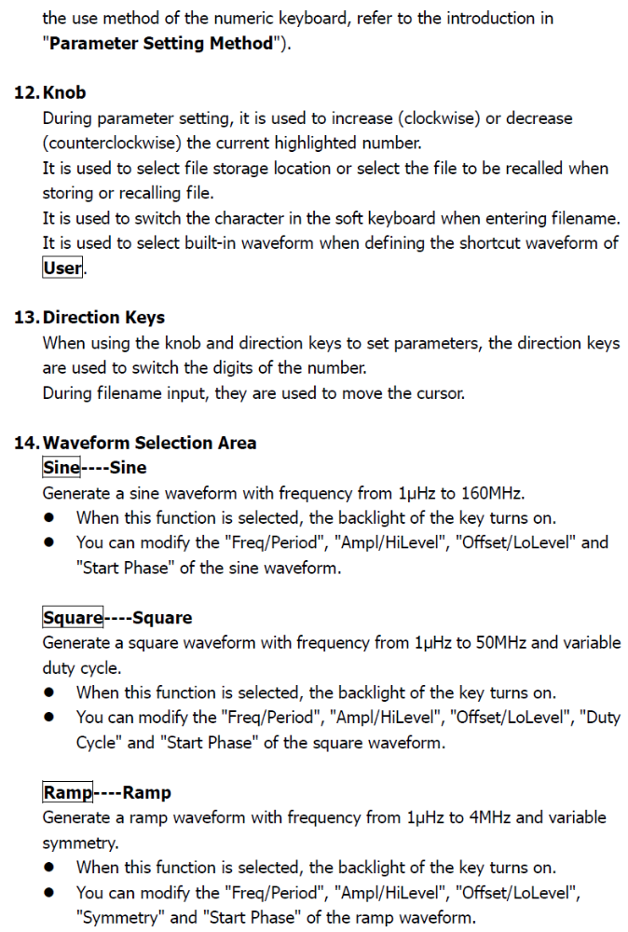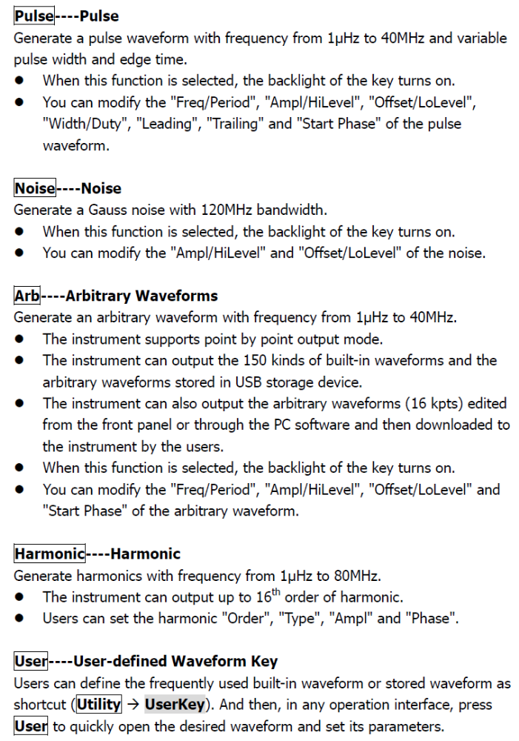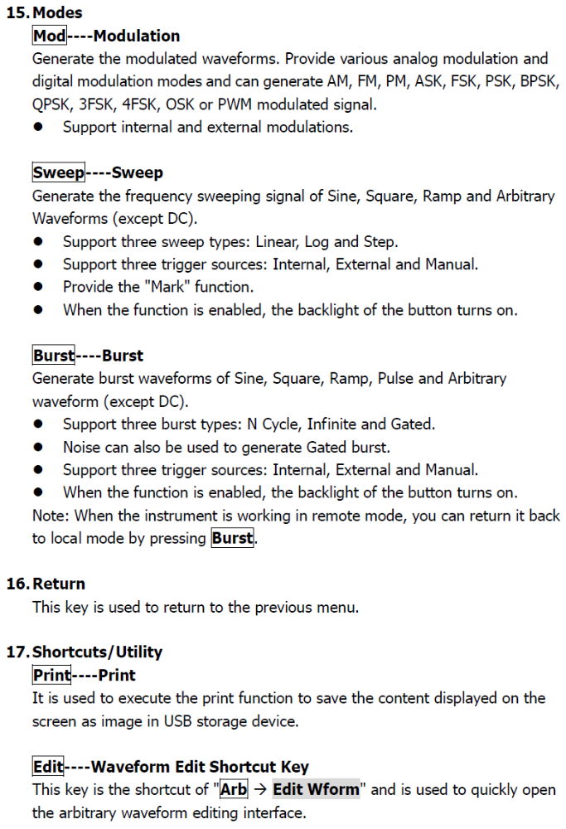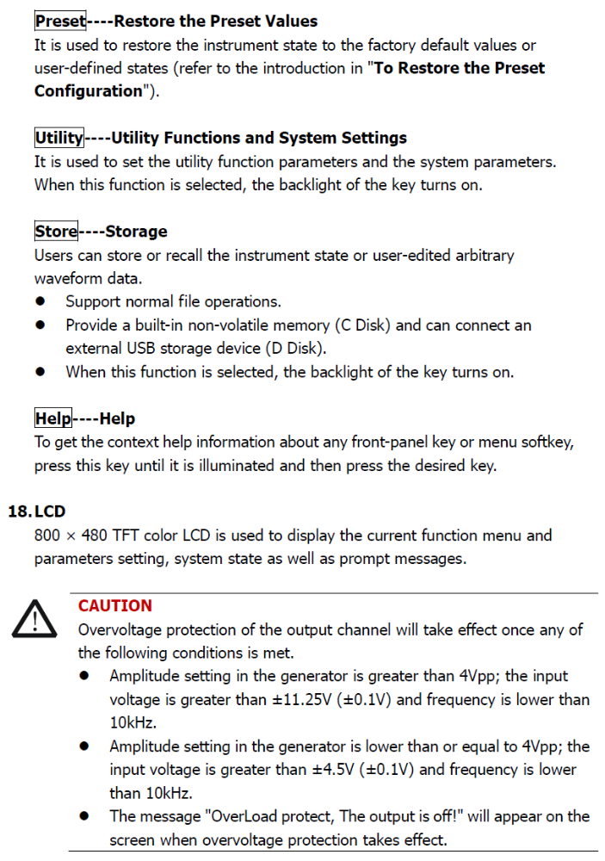

OSCILLOSCOPE BASICS

The RIGOL DS2072A oscilloscope shown in Fig. 3.2 is used in the lab.

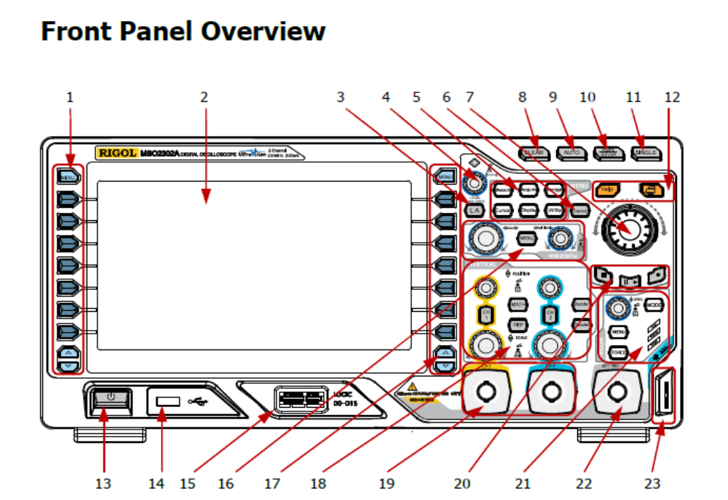
Figure 3.2 Front Panel Overview

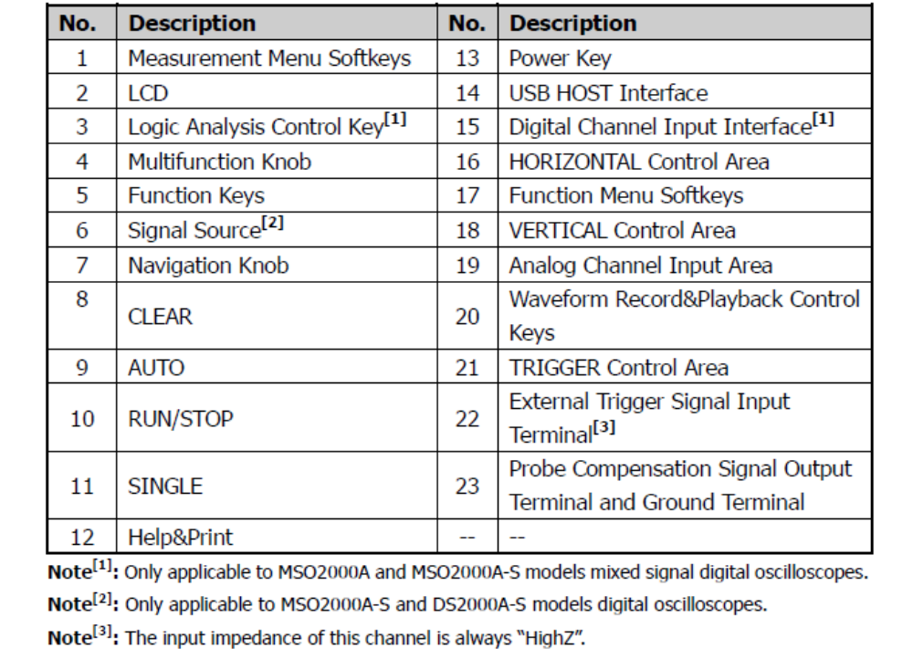
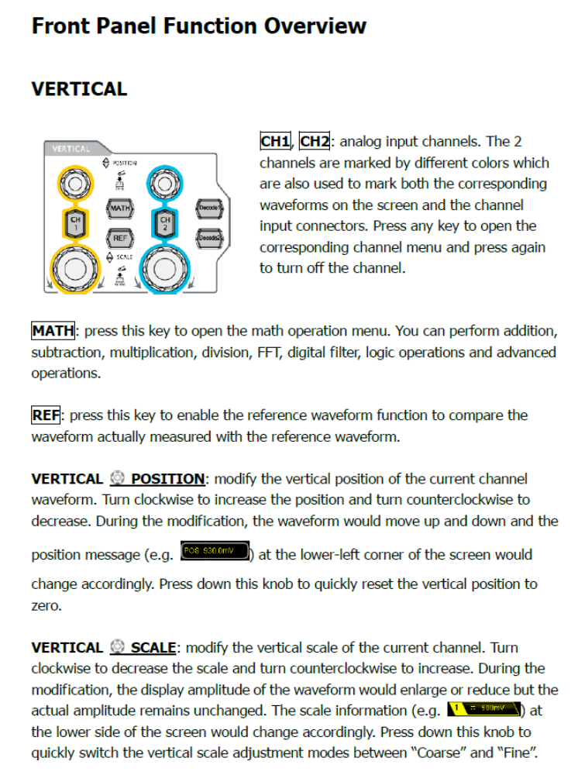
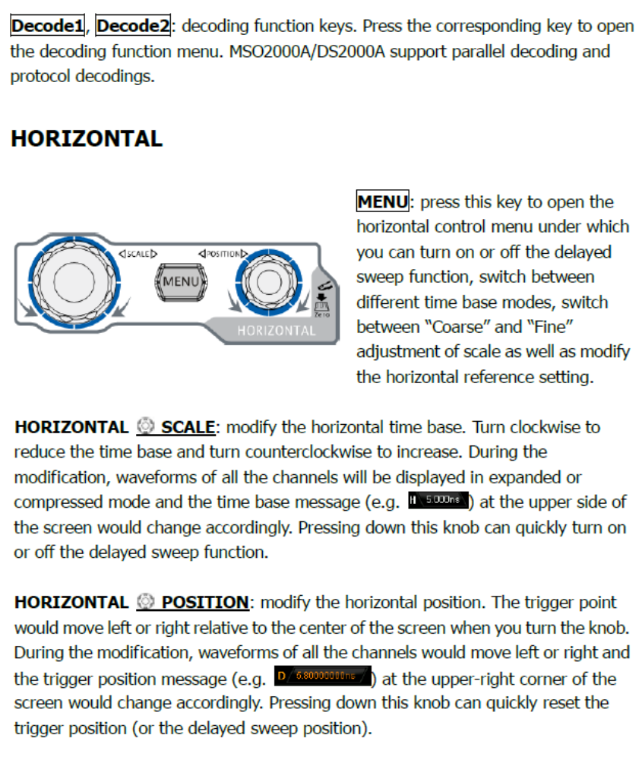

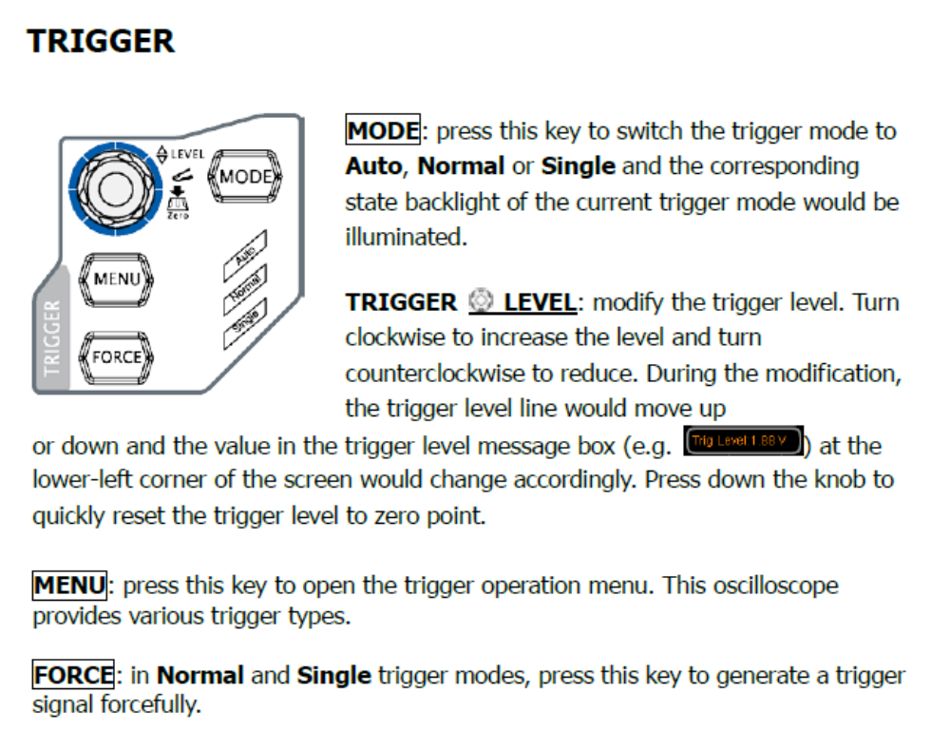
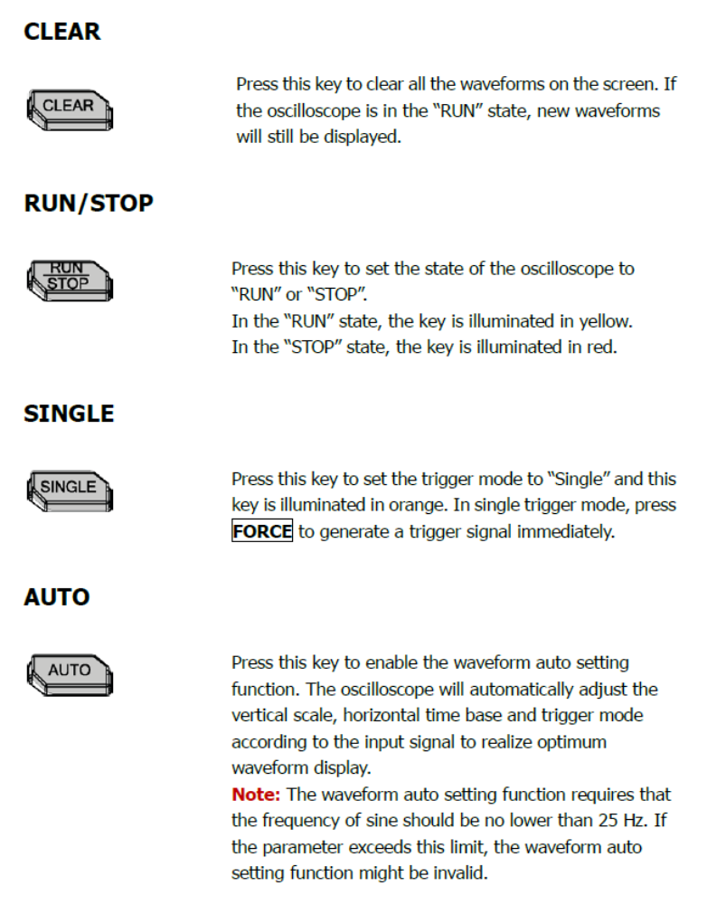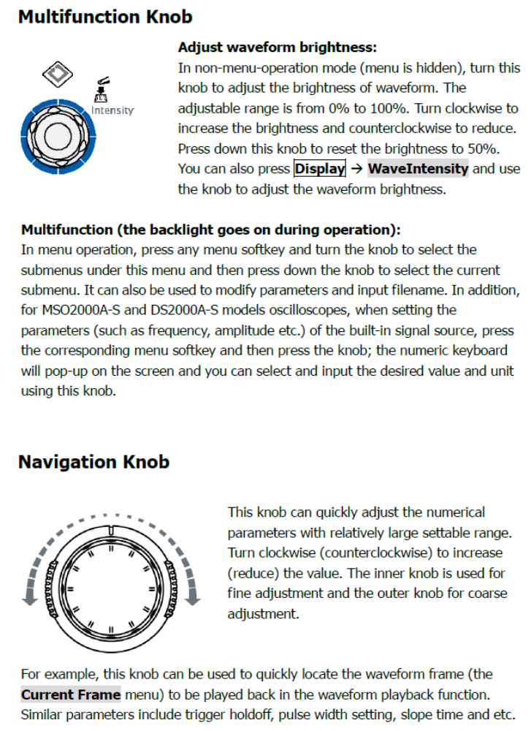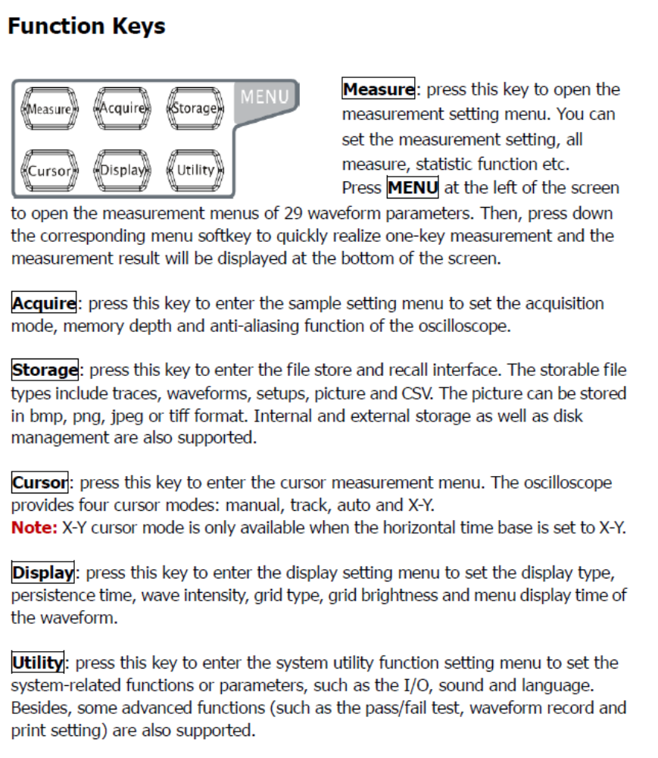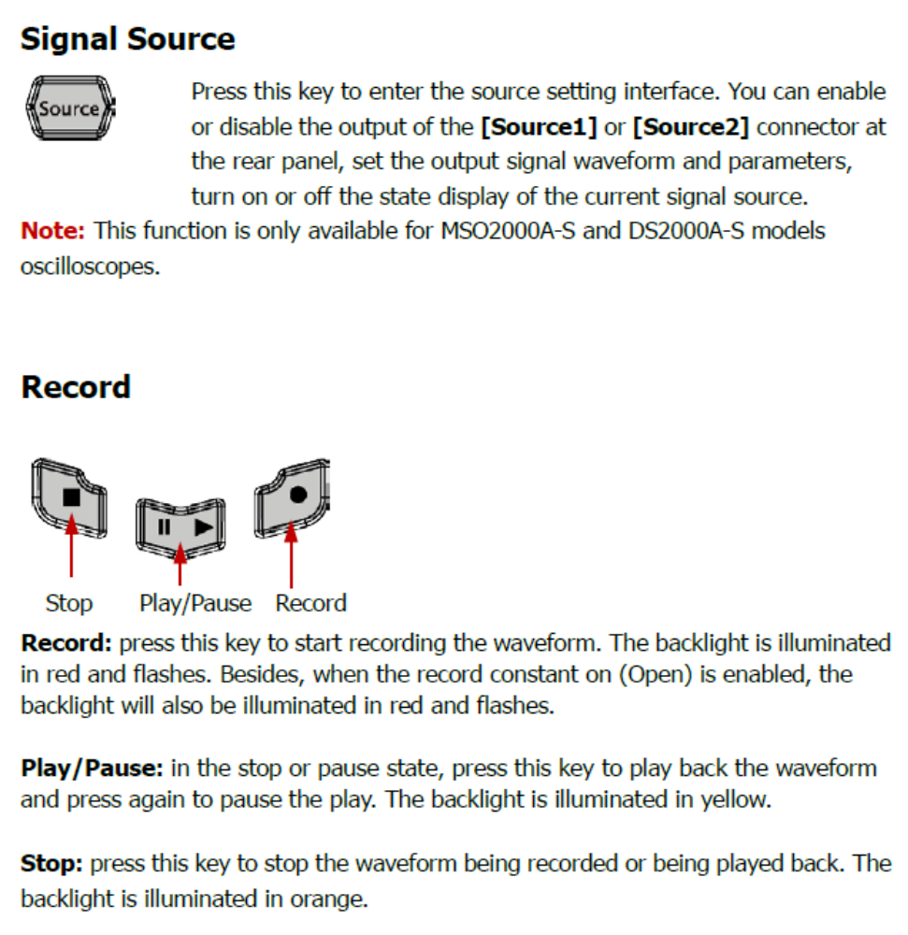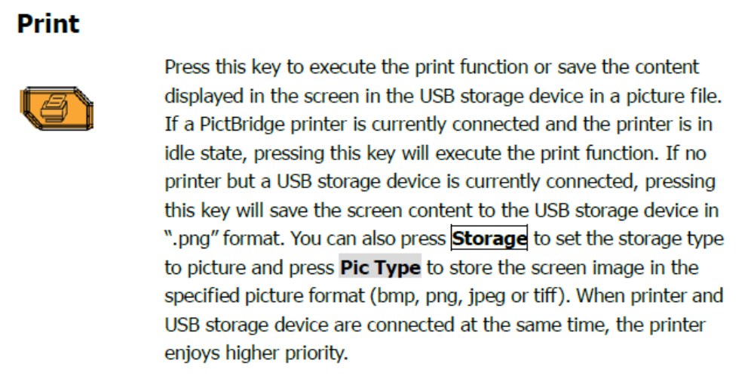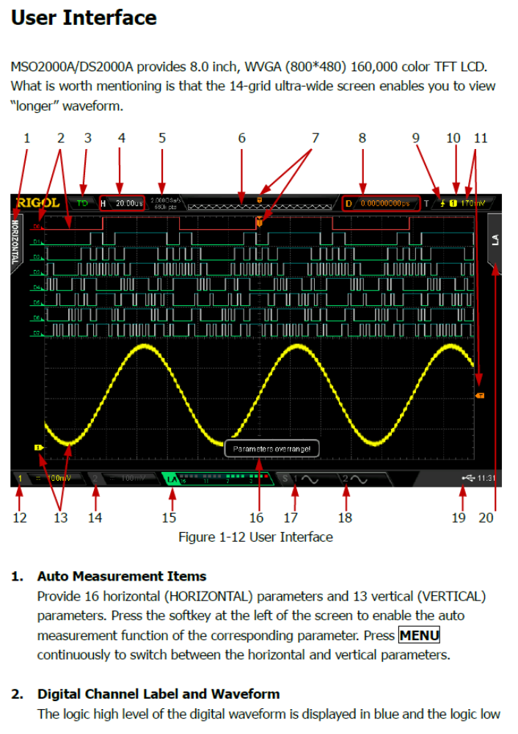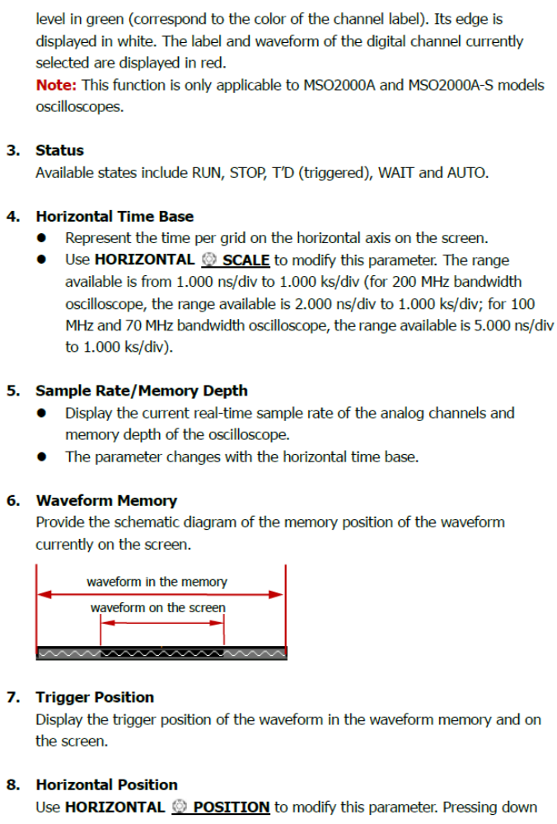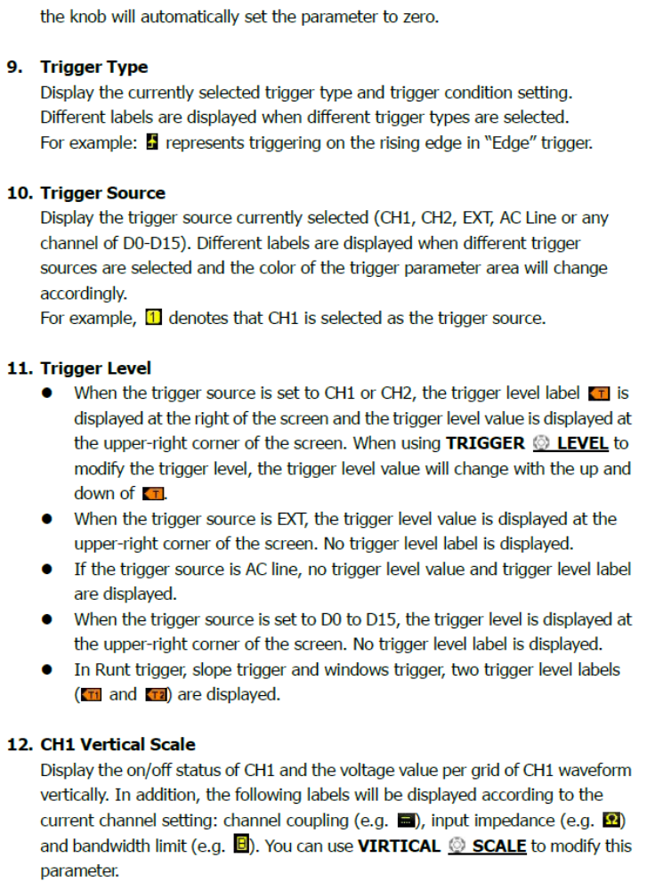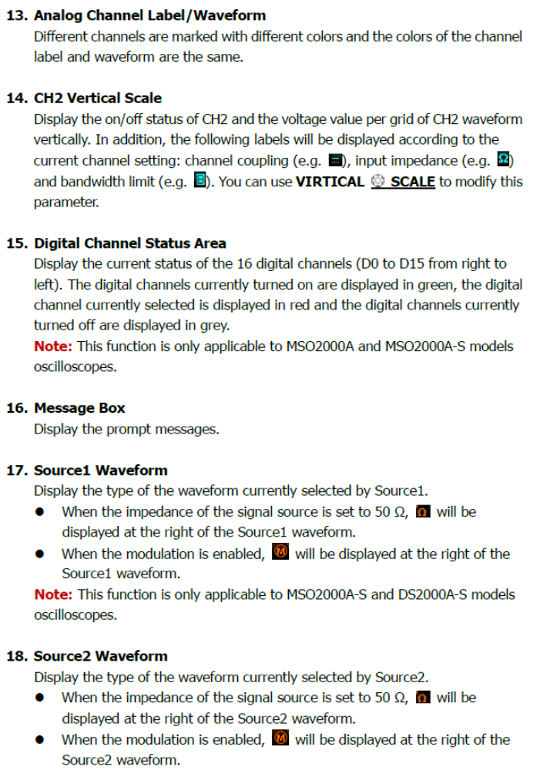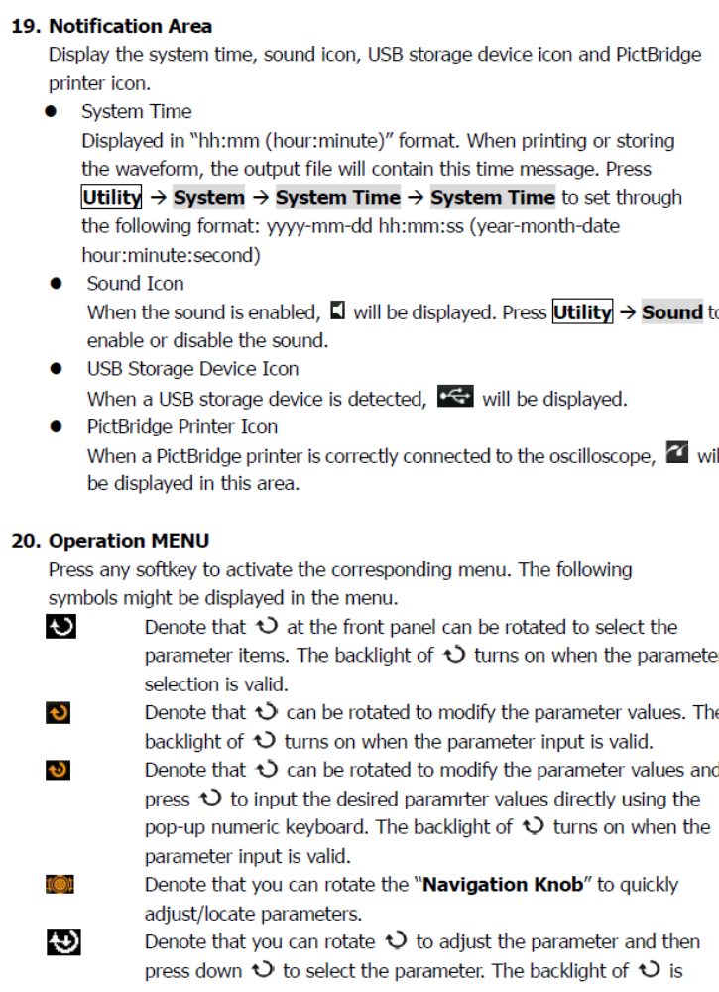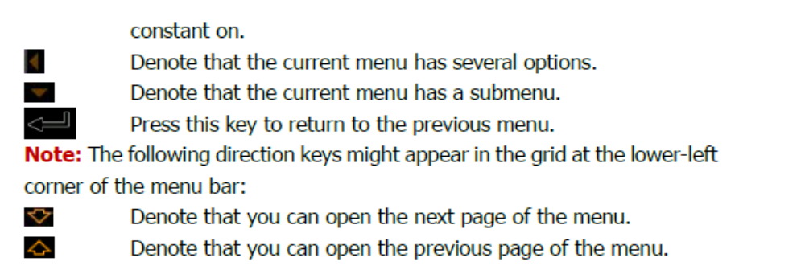

Task 1: Getting Started

- Turn on a function generator. The digital ones will take a few seconds to complete internal tests, but the analog ones will be ready right away.

- Turn on the digital oscilloscope.

- Get a couple of cables from the cable rack; six-foot lengths should be adequate. Use the cables to connect the “main” output of the generator to CH1 of the oscilloscope and the “aux” (or “sync” or “TTL”) output to CH2.

- Set the controls of the function generator to produce a sine wave of about 1000 Hz frequency and a few volts amplitude.

- Now that you have a signal, explore the effects of the various scope controls. Refer to Fig. 3.2 to help you locate the controls on your scope.

Task 2: Vertical.

- Press the CH1 button and see what happens when you turn the POSITION and VOLTS/DIV knobs. Pay attention to both the changes in the displayed waveform and the text indicators on the screen. You should be able to deduce the meaning of these indicators.

- Press the CH2 button and repeat the above step.

- You can turn a waveform off by first pressing the channel selector button (turning the adjacent green LED on), followed by the WAVEFORM OFF button. Try this, and turn off and then on the waveforms from channel 1 and channel 2.

- Press the VERTICAL MENU button and study the various options that are controllable by the softkeys.

Task 3: Horizontal

Adjust the POSITION and SEC/DIV knobs and see what happens. Notice that both the sample rate and the sweep rate depend on the setting of the SEC/DIV knob.
Task 4: Making measurements with a scope

- Use the generator to create a 2100 Hz triangle wave of approximately 2.4 volts peak-to-peak amplitude. Feed this signal into CH1 of the digital scope and get a stable trace showing this signal.

- You should see something similar to Fig. 3.3.

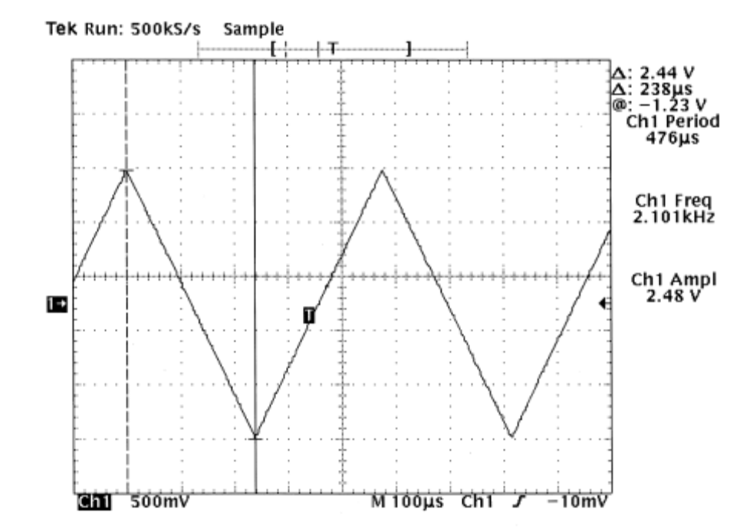
Figure 3.3

- Now, measure the amplitude and frequency of this signal by three different methods:

Method 1: Use the graticule.
This method works with any oscilloscope. Compare your waveform to the markings on the screen and use them along with the horizontal and vertical settings to calculate the amplitude and frequency. For example, in Fig. 3 the vertical peak-to-peak extent of the waveform is a little less than 5 large divisions (more accurately, about 4.9 large divisions), and the vertical sensitivity is 500mV/div, so the peak-to-peak amplitude is 4.9 × 500mV = 2.45V. The horizontal extent corresponding to one full period is a bit less than 4.8 large divisions, and the sweep rate is 100µs/div, so the period is 4.8×100µs = 480µs, which gives a frequency of 1/(480 × 10−6 s) = 2080 Hz.

Method 2: Use the cursors.
The digital scopes (and some advanced analog scopes) have cursor markers that can be used to ease the challenge of converting graticule distances to time and voltage units.

Method 3: Use the automated measurement function.
If you are using a digital scope and you have a very uniform stable waveform, like a sine, triangle or square wave, you can use the easiest method of all: automated measurements.

- Record and compare the three measurements in a table.

